**1. Fundamental Counting Principle**

Counting is much more than counting from 1-100. It includes counting how many ways things occur. You can make a list, a chart, or even a tree diagram so you can count things in a systematic order but these things can take time and are not always practical. So we can use the Fundamental Counting Principle to count things quicker. It involves multiplying which is a much quicker way of adding or counting things.

**Fundamental Counting Principle:** (Gina’s interpretation)

you have **n1** number of ways to do one thing and

you have **n2** number of ways to do a second thing and

you have **n3** number of ways to do a third thing,

then the total number of ways to do all things can be found by multiplying:

n1 ⋅ n2 ⋅ n3 ⋅ ……… ⋅ nk = total

**EXAMPLES:** Use the Fundamental Counting Principle to count the items:

1. If three ordinary dice are rolled, one red and one white and one blue, then how many result are possible?

Red Dice –

White Dice –

Blue Dice –

1. [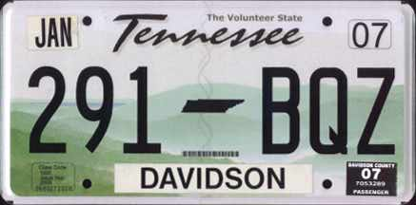](http://www.15q.net/us5/tn07.jpg#tennessee%20license%20plates)Sometimes license plates have 3 letters (A – Z) followed by 3 numbers (0 – 9) for example, ABC 123. Would this provide enough different license plates for a state with 8 million vehicles?

=

1. How many 3-digit numbers can be created using only the numbers 4, 5, 6 if repeated numbers are allowed?

**Sometimes restrictions may apply:**

1. How many 3-digit numbers can be created using only the numbers 4, 5, 6 if the **numbers cannot be repeated**?

**Sometimes restrictions may apply:**

1. How many 7-digit telephone numbers are possible if the **first digit *cannot* be a 0**?

=

1. If an ice-cream shop has 6 of my favorite flavors of ice-cream and 3 waffle cones, plus 5 delicious toppings, how many different ice-cream cone sundaes can I create?

Ice cream –

Cones –

Toppings –

1. Five students win an award: 3 guys and 2 girls. How many ways can all five winners line up for a photograph for the newspaper?
2. How many ways can we select 1 guy and 1 girl from the award winners above to plan a reception for family and friends?

**2. Factorial**

Did you notice in example #7 above the pattern of the numbers? Five students win an award. How many ways can all five winners line up for a photograph for the newspaper?

First Second Third Fourth Fifth

Person Person Person Person Person

=

Numbers that are multiplied like this are common in counting, probability, and statistics. This product has a special name called a ***factorial*** and the symbol used is an exclamation point ***!***

Factorial is an ***arrangement*** of one distinct group of items.

**Factorial Formula:** For any counting number, ***n***, the quantity/answer for n factorial is:

**n! = n(n – 1)(n – 2)…(3)(2)(1)** and **0! = 1**

meaning that ***n*** is the given number, them multiply by one less, until you reach the number 1

**For example:** What is 6! (6 factorial)

**EXAMPLE:** Try these factorial problems. Use the factorial button on your calculator.

Hit your **MATH** button, then arrow over to **PRB** (probability), then your factorial button

should be #**4: !**

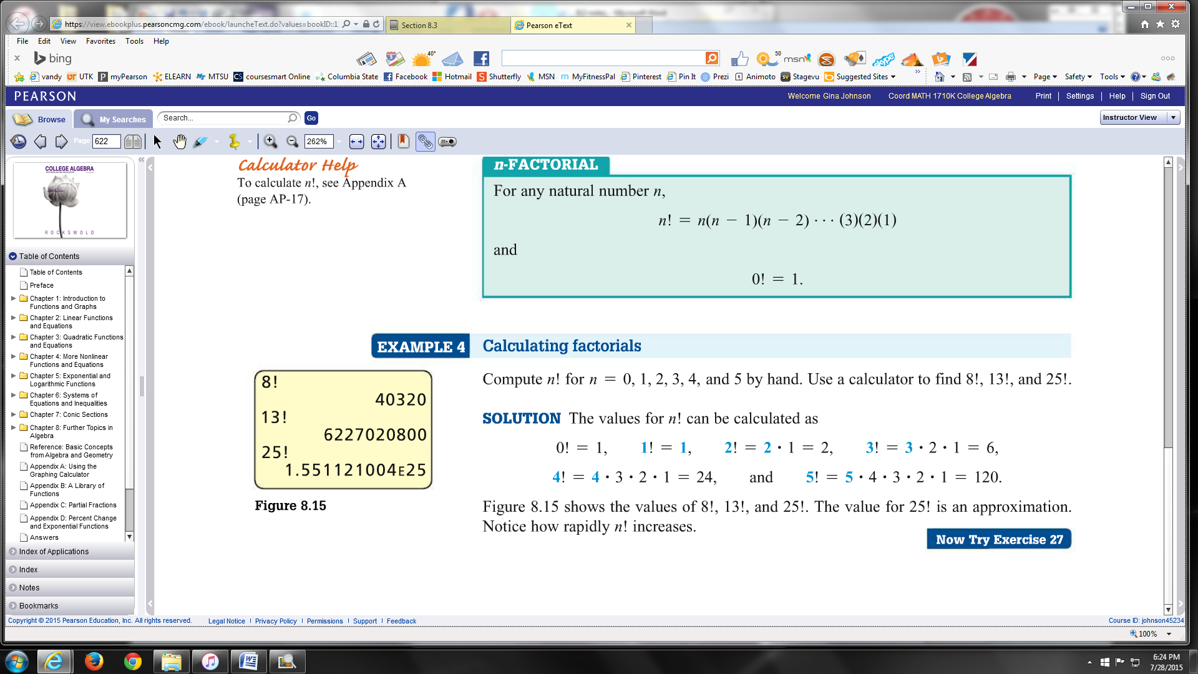

(1) 8! =

(2) 13! =

(3) $\frac{9!}{7!}=$

(4) $\frac{5!}{\left(5-2\right)!}=$

(5) $\frac{5!}{10! 10!}=$

(6) Determine the number of distinguishable arrangements of the letters in each

word: (a) ATTRACT (b) NIGGLING

Each letter can only be used one time, so this is a factorial problem.

However, some letter are already repeated so we divide by the repeated

letters so there are no repeated arrangements of letters.

(a)

(b)